Name: ___________________

Class: ____________________

**2.2 – Periodic Table**

**Elements: The Building Blocks of Matter**

* Matter can have a lot of ____________, but all of it can be broken down into the ___________________​
  + _______ elements occur ______________ on Earth​
* Ex: oxygen, gold, sulfur, carbon​
* Other elements are __________________ (ie: human-made)

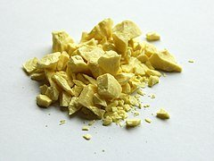

Figure 1. Solid sulfur, one of the elements that occur naturally on Earth. What are some of the properties or compounds of sulfur you know?

**Element Names & Symbols**

* Every element has a unique _____________ and ______________​
* Symbols of ________________ elements are _________ or _____________ letters long​
* First letter is always ______________ and any other letters are always ________________​
* Can be named for:​
  + ___________________________ (ex: Hydrogen)​
  + ___________________________(ex: Sodium)​
  + ___________________________ (Tungsten)​
  + ___________________________ (ex: Californium)​
  + ___________________________ (ex: Curium)​
  + ___________________________ (ex: Promethium)​

​

**Organization of the Elements**

* By the mid-19th century, almost _______ elements had been discovered​
* Scientists wanted to organize by ____________________, but weren't sure how​
* 1860s --> some tried to sort by ____________________​
* __________________________ --> Russian teacher and chemist wrote data cards for each element known at the time​
* Wanted to see _____________________ in various properties​

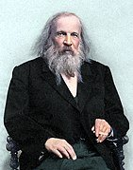

Figure 2. Dmitri Mendeleev, the father of the modern periodic table. What did some attempts at organizing the elements other than Mendeleev’s look like?

**Mendeleev’s Predictive Powers**

* Mendeleev recognized patterns in elemental _______________________​
* Recognized that he needed to leave ________________ for ________________________________​
* Accurately predicted the properties of elements that would be later discovered (ex: ______________________, __________________________, ________________________)​

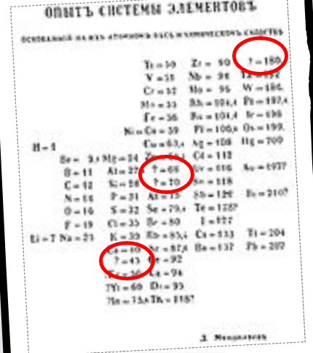

Figure 3. Data written by Mendeleev. What elements represented by question marks in his notes are now known to us?

**Modern Periodic Table**

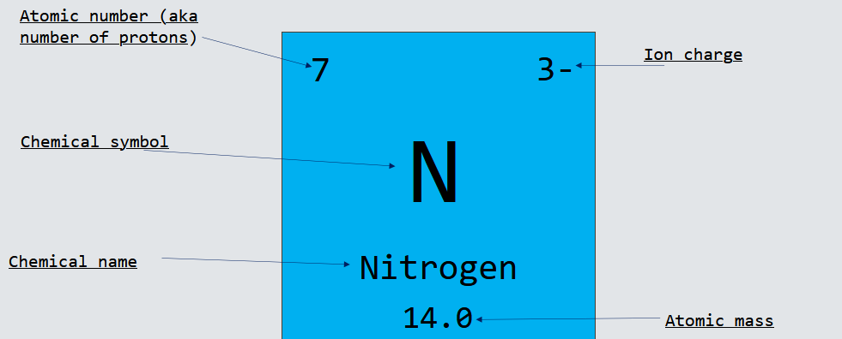Figure 4. Breakdown of nitrogen on the periodic table. What are five things you can tell about nitrogen from this picture?

**Periodic Table Organization**

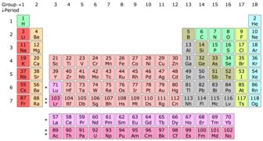

Figure 5. Periodic Table.

* Period = ____________________________________​
  + ​elements in same period don't share many __________________________
* Group (aka _______________________) = _______________________________​
  + elements in same family share many ________________________________

**Metals**

* Most elements are __________________________​
* Found on left side of periodic table​
* Metal means:​
  + _______________________​
  + _______________________​
  + _____________________________________________​
  + _____________________________________________​
  + ________________________________________​
  + ________________________________________​

**Common Metal Groups**

Alkali Metals:​

* ____________________ column of periodic table (excluding __________________________)​
* Shiny​
* Soft​
* Extremely ____________________________ --> must be stored under ______________ to avoid reacting with __________________ and oxygen in _________________​



Alkaline Earth Metals:​

______________ column of periodic table​

Also shiny and soft, but not as much as _________________________

Also______________________, but not as much as alkali metals​

​

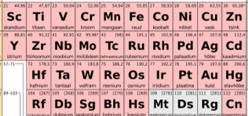

Transition Metals:​

Have many of the common qualities as ___________________​

Much less ______________________ than alkali metals and alkaline earth metals​

**Non-Metals**

* Found on ______________________________of periodic table**​**
* Also includes ______________________​
  + Over ______________ of atoms in the universe are hydrogen​
* Typically _________________ or ___________________________ solids​
* Poor _____________________________ of heat and electricity​
* Not __________________, __________________________, or _________________________​

**Common Nonmetal Groups**

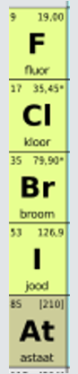

Halogens:​

* __________ column on periodic table​
* Extremely ___________________​
* Most are ___________ at room temperature​
* Exception: __________ --> 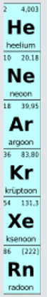____________

Noble Gases:​

* _________ group on periodic table​
* _______________________________​
* Least _________________ of all elements​
* ​

**Semi-Metals**

* Aka ______________________​
* Boron, silicon, germanium, arsenic, antimony, & tellurium​
* In-between --> have some properties of ______________ & some of ______________________​
* Metal properties --> ______________________​
* Nonmetal properties --> poor __________________, not ________________, __________________​

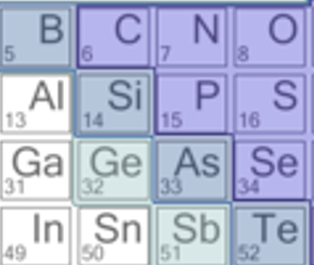

Figure 6. Semi-metals are B, Si, Ge, As, Sb, and Te.