Name: ___________________

Class: ____________________

**2.2 – Periodic Table**

**Elements: The Building Blocks of Matter**

* Matter can have a lot of forms, but all of it can be broken down into the elements​
  + ~90 elements occur naturally on Earth​
* Ex: oxygen, gold, sulfur, carbon​
* Other elements are synthetic (ie: human-made)

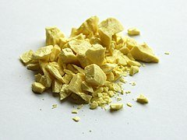

Figure 1. Solid sulfur, one of the elements that occur naturally on Earth. What are some of the properties or compounds of sulfur you know?

**Element Names & Symbols**

* Every element has a unique name and symbol​
* Symbols of known elements are one or two letters long​
* First letter is always capital and any other letters are always lowercase​
* Can be named for:​
  + Greek words (ex: Hydrogen)​
  + Latin words (ex: Sodium)​
  + German words (Tungsten)​
  + Places (ex: Californium)​
  + Famous scientists (ex: Curium)​
  + Mythical figures (ex: Promethium)​

​

**Organization of the Elements**

* By the mid-19th century, almost 60 elements had been discovered​
* Scientists wanted to organize by shared properties, but weren't sure how​
* 1860s --> some tried to sort by atomic mass​
* Dmitri Mendeleev --> Russian teacher and chemist wrote data cards for each element known at the time​
* Wanted to see patterns in various properties​

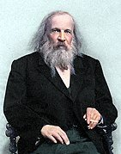

Figure 2. Dmitri Mendeleev, the father of the modern periodic table. What did some attempts at organizing the elements other than Mendeleev’s look like?

**Mendeleev’s Predictive Powers**

* Mendeleev recognized patterns in elemental properties​
* Recognized that he needed to leave gaps for undiscovered elements​
* Accurately predicted the properties of elements that would be later discovered (ex: scanadium, gallium, germanium)​

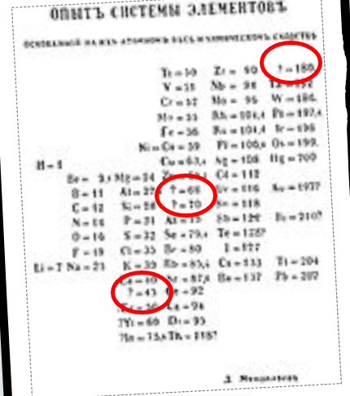

Figure 3. Data written by Mendeleev. What elements represented by question marks in his notes are now known to us?

**Modern Periodic Table**

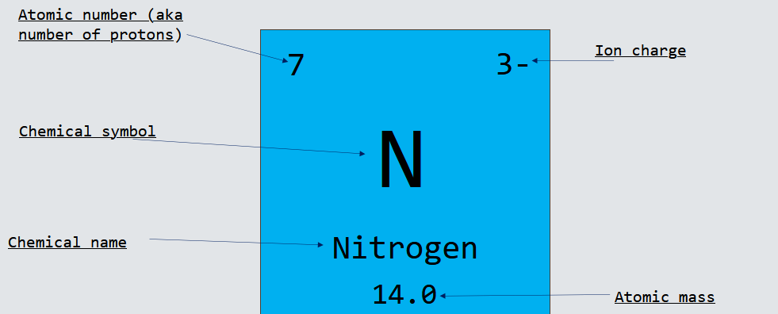Figure 4. Breakdown of nitrogen on the periodic table. What are five things you can tell about nitrogen from this picture?

**Periodic Table Organization**

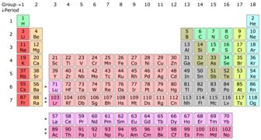

Figure 5. Periodic Table.

* Period = horizontal row​
  + ​elements in same period don't share many properties
* Group (aka family) = vertical column​
  + elements in same family share many properties

**Metals**

* Most elements are metals​
* Found on left side of periodic table​
* Metal means:​
  + hard ​
  + shiny ​
  + malleable (can be flattened into sheets)​
  + ductile (can be drawn into wires)​
  + conducts electricity and heat​
  + typically silver or gray​

**Common Metal Groups**

Alkali Metals:​

* 1st column of periodic table (excluding hydrogen)​
* Shiny​
* Soft​
* Extremely reactive --> must be stored under oil to avoid reacting with water and oxygen in air​



Alkaline Earth Metals:​

2nd column of periodic table​

Also shiny and soft, but not as much as alkali metals​

Also reactive, but not as much as alkali metals​

​

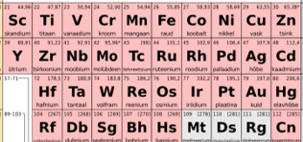

Transition Metals:​

Have many of the common qualities as metals​

Much less reactive than alkali metals and alkaline earth metals​

**Non-Metals**

* Found on upper right sideof periodic table**​**
* Also includes hydrogen​
  + Over 90% of atoms in the universe are hydrogen​
* Typically gases or brittle, dull solids​
* Poor conductors of heat and electricity​
* Not shiny, malleable, or ductile​

**Common Nonmetal Groups**

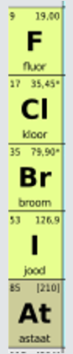

Halogens:​

* 17th column on periodic table​
* Extremely reactive​
* Most are gases at room temperature​
* Exception: Bromine --> 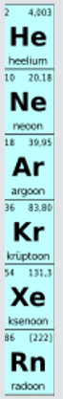liquid

Noble Gases:​

* 18th group on periodic table​
* Odourless, colourless gases​
* Least reactive of all elements​
* ​

**Semi-Metals**

* Aka metalloids​
* Boron, silicon, germanium, arsenic, antimony, & tellurium​
* In-between --> have some properties of metals & some of non-metals​
* Metal properties --> shiny solids​
* Nonmetal properties --> poor conductors, not ductile, brittle​

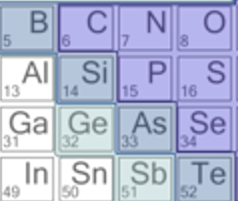

Figure 6. Semi-metals are B, Si, Ge, As, Sb, and Te.